

Foundations of Programming
Assignment No. : 12

PROBLEM STATEMENT:
Write a program in C to accept two numbers from the user and compute:
- The smallest common divisor of the two numbers (other than 1, if any)
- The Greatest Common Divisor (GCD) of the two numbers

OBJECTIVE:
• To understand the use of mathematical operations in C.
• To implement loops and conditional statements
. • To perform number-based computations.
• To enhance logical thinking using menu-driven programs.

THEORY:
Divisors and the Greatest Common Divisor (GCD) are fundamental concepts in number theory. The smallest common divisor of two numbers is the smallest positive integer greater than 1 that divides both numbers. The GCD of two numbers is the largest positive integer that divides both numbers without leaving a remainder. In C programming, these operations can be efficiently implemented using loops and the Euclidean algorithm, which repeatedly applies the modulo operation until the remainder becomes zero.

PLATFORM:
Linux

ALGORITHM:
1) Start
2) Read two positive integers a and b.
3) While b ! = 0 :
- Compute b = a % b
- Swap a and b (effectively replace the pair (a, b) with (b, a % b) – this is the standard Euclidean algorithm step).
4) When the loop ends (b == 0), set GCD = a.
5) Initialize i = 2.
6) While i² ≤ GCD:
- If GCD % i == 0:
  - Set LCD = i (this is the smallest common divisor of the original two numbers that is greater than 1).
  - Display LCD.
  - Display GCD.
  - Go to Stop.
- Else:
  - i = i + 1
7)Display “number other than ‘1’
8)Stop

FLOWCHART: 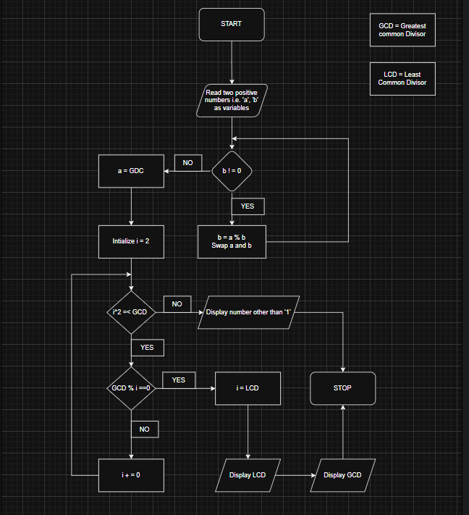

C PROGRAM: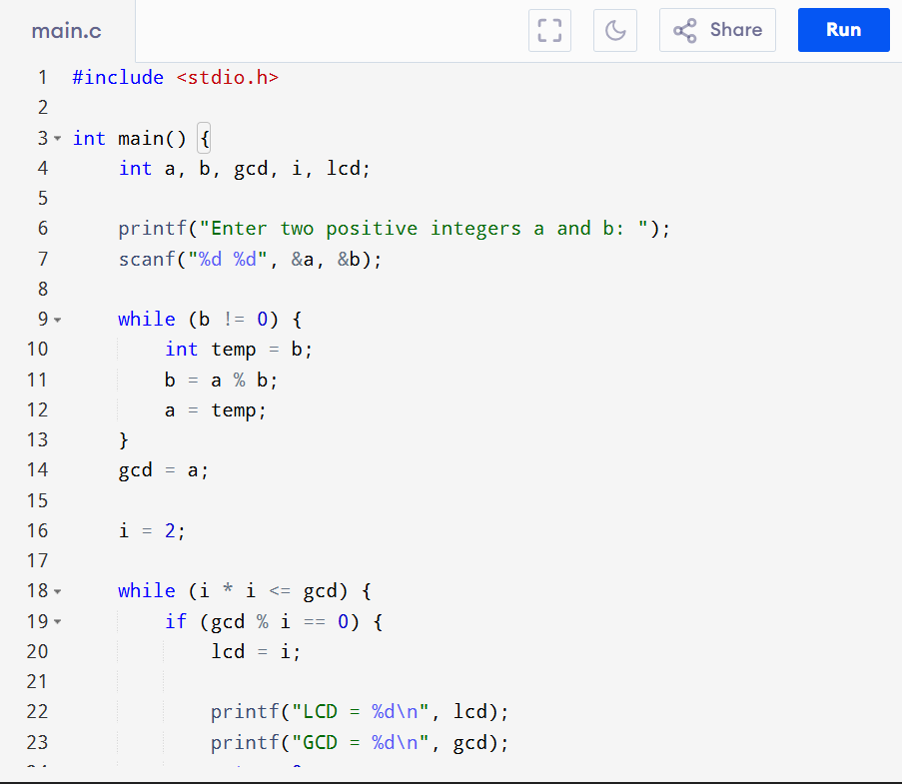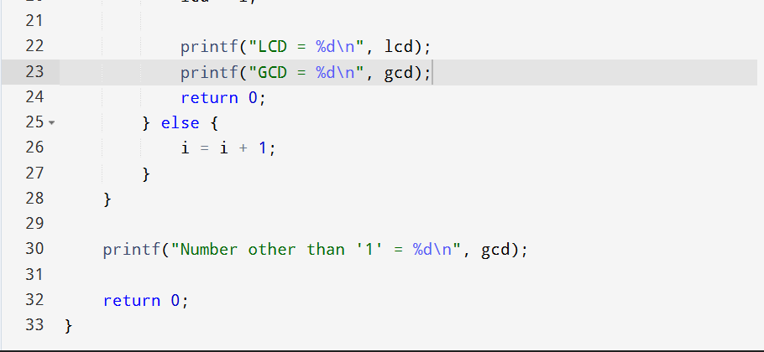

INPUT:

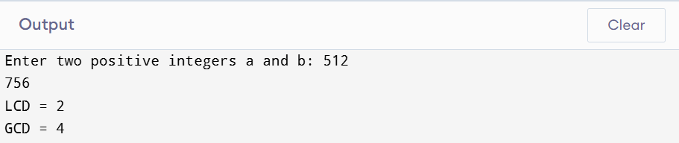

OUTPUT:


CONCLUSION:
Thus, the program to find the smallest common divisor and the Greatest Common Divisor of two numbers was successfully implemented using C programming. This program demonstrates the use of loops, conditional statements, and the Euclidean algorithm.

